Grade 6
True or false?
- The internet is a network of computers.
- Universal Resource Locator is the full form of URL.
- The email address is a combination of a username and a hostname.
- DNA is a medium of sending mails through the internet.
- A file sent in an email is called an attachment.
- By default, the name of the program file in QB64 is ‘Untitled’.
- BES is the extension of a QB64 program.
- QBASIC is designed from BASIC language.
- The ‘Exit’ option is used to save the changes in the program file.
- To exit from QB64, use the New option found in the File menu.
- Commas and semicolons are the two separators used with PRINT statements.
- Print is a name of the memory location.
- Variables are non-executable statements.
- To accept a value from the user, an input statement is used.
- % sign is used with string variables.
- Relational operators are used for combining two or more conditions.
- Logical operators are used when you want to make a comparison between any two values.
- The IF command is used for executing a statement based on the condition.
- Arithmetic operators are also called concatenation operators.
- Relational operators give a single value, which is either true or false.
Fill in the blanks.
- Numbers entered in MS Excel 2010 could be a value, ________________ or ________________ .
- You can format data using the ________________ option.
- Addition of two strings is called ________________ .
- ________________ error message is displayed when the text is not recognized.
- ________________ option can be used to find the GCD and LCM of two numbers.
Give one word for the following:
- Blind carbon copy
- Worldwide system of servers
- Username@hostname
- Unique address of a website
- Email server name

Give one word for the following:
- Runs a program. ________________________
- File extension in QB64. ________________________
- Helps to give a name to a file. ________________________
- Changes are saved. ________________________
- Command for clearing the screen. ________________________
- Command to display the output on the screen. ________________________
Write the formulae to get the following results.
- Add the values from cell A2:D2 and display the result in E2.
- Find the average of values from C2:E2.
- Find the minimum value from the numbers given in cells A2:A4.
- Find the maximum value from the numbers given in cells B1:B6.
- Find the count of values from cells A5:E12.
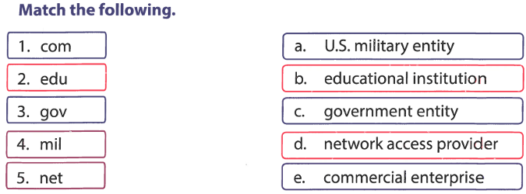
Question Answers.
What is QB64? How is it related to QBASIC?
Name the different components of the QB64 window.
What command do you give to clear the output screen?
How do you execute a program in QB64?
Why do you use the Save As... option?
What is a URL? Explain its format.
Why do you need an email address?
State the advantages and disadvantages of using email.
What do you mean by ‘composing an email’?
Why is it advisable to sign out of your email account properly?

Answers.
True or False
1. True – The internet is a global network of computers.
2. True – URL stands for Universal Resource Locator.
3. True – An email address combines a username and a hostname (e.g., user@example.com).
4. False – DNA is not related to emails; emails are sent digitally.
5. True – Files sent via email are called attachments.
6. True – QB64 defaults to ‘Untitled’ for new program files.
7. False – QB64 programs use the .bas extension, not BES.
8. True – QBASIC is derived from the BASIC programming language.
9. False – The Exit option closes the program; Save saves changes.
10. False – To exit QB64, use File → Exit, not New.
11. True – PRINT statements use commas (,) and semicolons (;) as separators.
12. False – PRINT is a command, not a memory location.
13. False – Variables are executable (used in operations).
14. True – INPUT statements accept user input.
15. False – % is used with integer variables; $ is for strings.
16. False – Logical operators (AND, OR) combine conditions; relational operators (>, <) compare values.
17. False – Relational operators (==, >) compare values; logical operators (AND, OR) combine conditions.
18. True – IF statements execute code based on conditions.
19. False – Arithmetic operators (+, -) perform math; concatenation (+ or &) joins strings.
20. True – Relational operators return True or False.

Fill in the Blanks
1. formula, text
2. Format Cells
3. concatenation
4. #NAME?
5. GCD & LCM (or Math Functions)

Give One Word
1. BCC
2. Internet
3. Email address
4. URL
5. wss
Give One Word (QB64 Commands)
1. Run
2. bas
3. Save As
4. Save
5. CLS
6. PRINT

Formulae for Excel
1. =SUM(A2:D2)
2. =AVERAGE(C2:E2)
3. =MIN(A2:A4)
4. =MAX(B1:B6)
5. =COUNT(A5:E12)

Question Answers
1. What is QB64? How is it related to QBASIC?
Ans. QB64 is a modern version of QBASIC.
2. Name the different components of the QB64 window.
Ans. Menu bar, Editor, Output screen, Status bar.
3. What command clears the output screen?
Ans. CLS
4. How do you execute a program in QB64?
Ans. Press F5 or select Run → Run.
5. Why use ‘Save As…’?
Ans. To save a file with a new name or location.
6. What is a URL? Explain its format.
Ans. A website address (e.g., https://www.example.com). Format: Protocol://Domain/Path.
7. Why need an email address?
Ans. To send/receive digital messages and files.
8. Advantages & Disadvantages of Email:
Ans. Advantages: Fast, cost-free, eco-friendly.
Disadvantages: Spam, phishing, requires internet.
9. What is ‘composing an email’?
Writing a new email with a subject, body, and attachments.
10. Why sign out of email properly?
To protect your account to your account.

