Revision Worksheet for grade 4
Unit 3
P.60 Match the definitions to the words in the box:
( atmosphere – core- crust – mantle- continent )
a- The outside layer of the Earth ………………………..
b- The material at the center of the Earth …………………
c- The layer of gas that surrounds the Earth ……………………….
d- One of six large areas which form most of the dry land on the Earth …………
e- The layer of the Earth between the crust and the core ……………………………
Q2- Mark each of these statements as true ( T ) or false ( F )
a- The Earth’s diameter is about 12.800 kilometer. ( )
b- Nearly three quarters of the Earth’s surface is covered with water. ( )
c- The Earth gets cooler towards its center. ( )
d- The Earth’s crust is thicker under the oceans than under the continents. ( )
Q3- Label the diagram:
( core – mantle- crust- atmosphere )
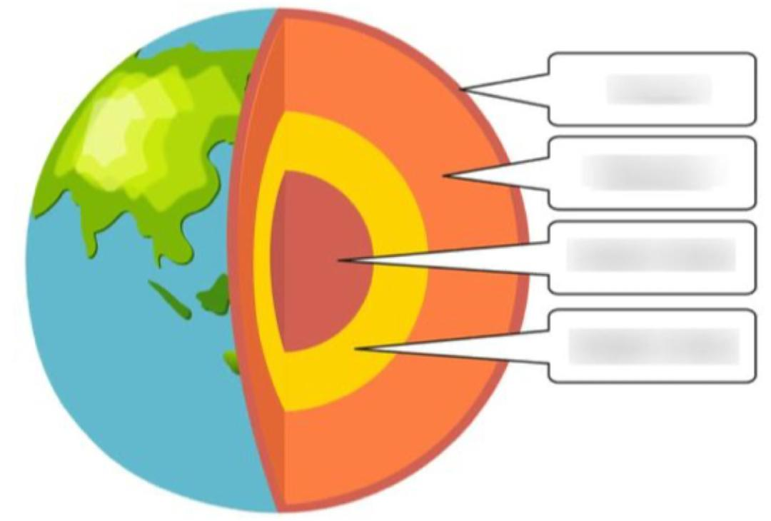
Q4- Label the diagram :
( seafloor crust- continental crust – ocean – land- mantle )
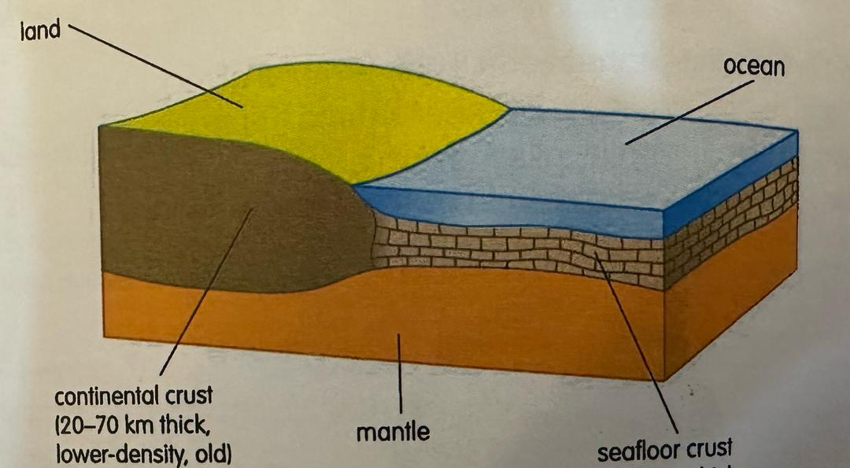
P.61:Q3- Match the definitions with the words in the box:
( aluminum- bauxite- lustre- texture- hardness)
a- Whether something is shiny or dull …………………..
b- How well a measured resists scratching ……………..
c- The rock from which aluminum is extracted……………
d- The feel of a surface rough or smooth ……………..
e- A light silvery metal ………………….
P.62: Q1- Match the definitions with the words in the box:
( sedimentary- metamorphic – igneous)
a- Rocks that form when molten rock cools ……………………
b- Rocks made from layers of mud and sand ( sediments ) that may collect on the bottom of lakes and ocean ………………….
c- Rocks that have been changed by heat and pressure …………………..

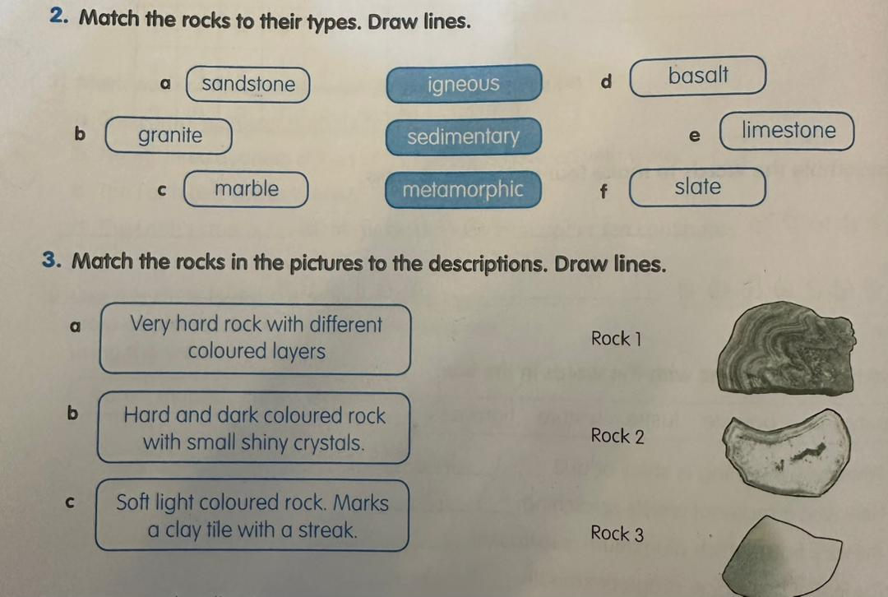
P. 63:1- Match the descriptions with the words in the box:
( mineral- quartz- crystal- grain- pure )
a- A piece of mineral with a regular shape …………………..
b- A hard mineral found in sand and many rocks ………………
c- Made from one substance only ……………..
d- A pure non-living substance ……………..
e- A tiny particle ……………..
3- Mark each of these statements as true ( T ) or false ( F )
a- Minerals are the remains of living things ( )
b- Sand is a mixture of mineral grains that have been broken from rocks ( )
c- Crystals have curved faces and edges ( )
d- All minerals are poisonous ( )
P.67
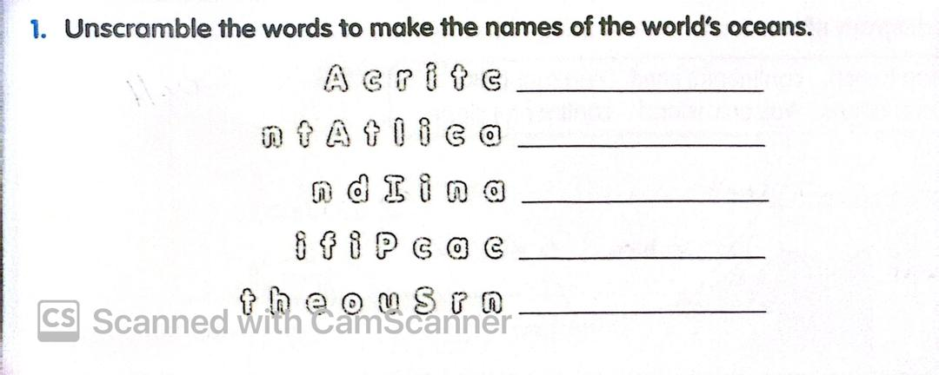
2- Match the definitions with the words in the box:
( lake- river- sea- ocean )
a- A branch of the ocean , not completely surrounded by land …………….
b- One of the large areas of salt water that covers most of the Earth ………..
c- A large body of water surrounded by land …………….
d- A large natural stream of flowing water ……………..

3- Mark each of these statements as true ( T ) or false ( F ):
a- Most of the water on the Earth is fresh ( )
b- All the world’s oceans are connected ( )
c- Most living things live on the land ( )
d- Less energy is used to transport goods by ship than by air or by land ( )
P.69 Q2 Match the definitions with the words in the box:
( tide – intertidal zone- tsunami )
a- The environment between low and high tides on the seashore …………………………
b- Twice- daily rise and fall of the ocean caused by the force of gravity from the moon and the sun ……………………….
c- A giant ocean wave created by an earthquake …………………
Answer these questions:
1- What is the earth made up of?
………………………………………………………………………………………………………………………………
2- What causes the tides?
……………………………………………………………………………………………………………………………..
3- What is the outer layer of the earth called?
………………………………………………………………………………………
4- List four properties you can describe a rock?
………………………………………………………………………………………………………………………………………………………………………………
5- Define minerals?
………………………………………………………………………………………………………………………………………………………………………………

Unit 4:
P.74
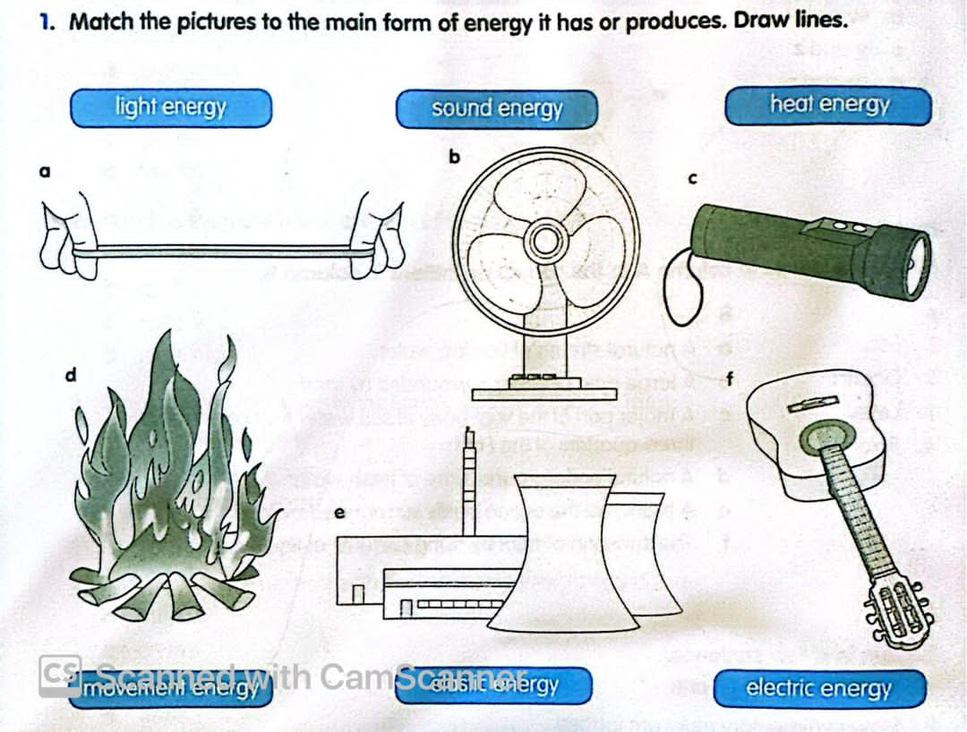
P.79:Mark each of these statements as true ( T ) or False ( F )
a- Sounds are made when something vibrates ( )
b- You cannot hear sounds underwater.( )
c- Sounds cannot travel through solids ( )
d- Sounds travel as waves ( )
Answer these questions:
Fill in the blanks by using the following words:
( vibrates- electricity- heat )
a- Solar panels trap solar energy as …………………….
b- Sounds are made by something that ……………………
c- Solar cells convert solar energy as ………………………
Answer these questions:
What are fossil fuels?
…………………………………………………………………………………………………………………………………………………..
How does a sound travel from a sound source to your ear?
………………………………………………………………………………………………………………………………………………….
Describe two instruments that help us hear sounds ?
………………………………………………………………………………………………………
What is vibration?
………………………………………………………………………………………………………………………………………………………………………………
Unit 5:
P.88 Q2- Match the words to their definitions . Draw lines:
A | B
Planet | A huge ball of blazing gas in space
Star | A star and all the objects that orbit it in space
Orbit | A very large round object in space that orbits a star
Solar system | The path a planet , a moon or something else follows around another planet
P. 90 Label the diagram:
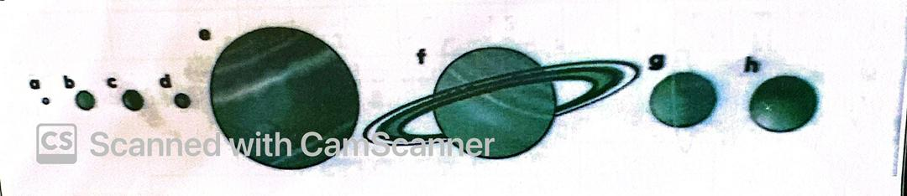
Answer these questions:
1- Which is the biggest planet in the solar system? ……………………………………..
2- Which is the smallest planet in the solar system ? …………………………………..
3- What is at the centre of the solar system? …………………………………….

