Grade 3 science monthly test practice sheet

Unit 10: KEEPING FOOD CLEAN AND SAFE
Question and Answers
Q1. What are germs?

Ans :________________________________________________________
Q2. Name some different ways we can preserve stored food.

Ans: _______________________________________________________________________

____________________________________________________________________
Q3: How can food become contaminated?
Ans: _________________________________________________________________________

Q4: Why is it dangerous to eat fruit and vegetables that have not been Washed?

Ans: __________________________________________________________________
Choose the correct answers:-
- Germs need warmth, moisture, and _____to breed.
- Light (b) Food (c) Soap
- Dirty hands ____________ food with germs.
- Preserve (b) Sterilize (c) Contaminate
- When we prepare and handle food we must practice proper ___________
- Hygiene (b) Humour (c) Hunger
- It is safest to eat cooked food when it is ________
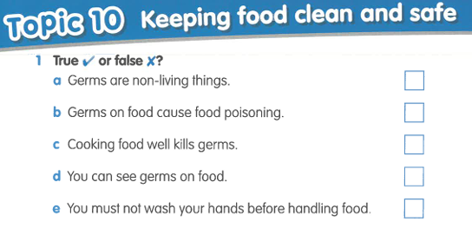
- Cold (b) Hot (c) Contaminated

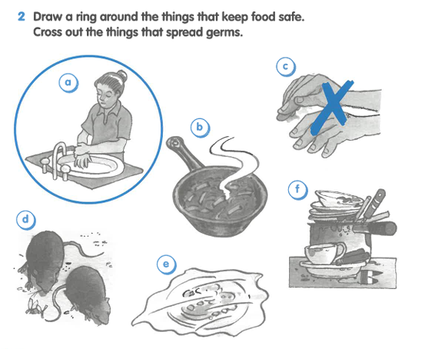

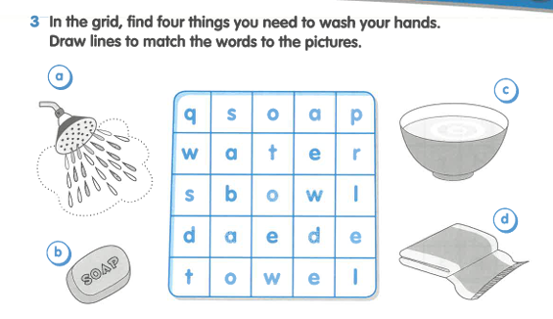

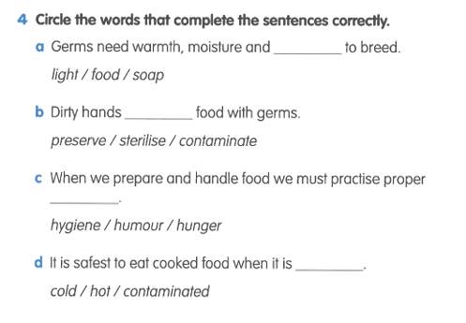

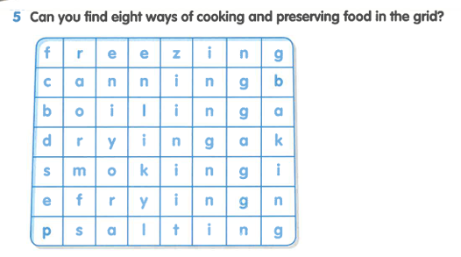

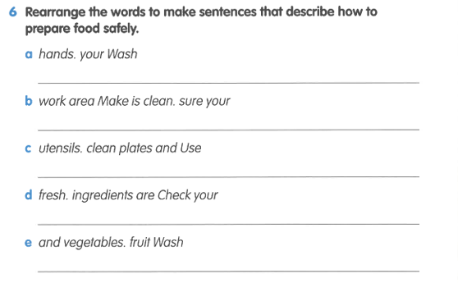

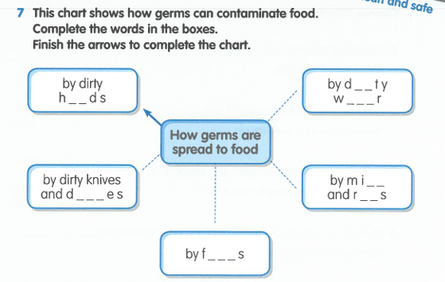

Unit 11: WHAT IS MATTER?
Question and Answers
Q1. What is Matter?
Ans: __________________________________________________________________

____________________________________________________________________

Q2: What is Mass?
Ans: __________________________________________________________________

___________________________________________________________________
Choose the correct answers.
- Everything around us is made from _______.
- Light (b) Water (c) Matter.
- All matter takes up space and has _______ .
- Motion (b) Mass (c) Magnetism.
- To find the mass of an object, you weigh it on a ________.
- Balance (b) Thermometer (c) Clock
4.Mass is a measure of the amount of matter something _________.
- Dissolves (b) Boils (c) Contains.

