Grade 5 Computer Solution
Fill in the blanks.
- Duplicating the text means ........Copying.......... the selected text from one location and .... Paste........ it in another location.
- ......Alignment............ means to arrange the text according to a chosen pattern.
- A ..........Theme.... is a template with a specific design that can be applied to a slide or to the entire presentation?
- .......Image........... in a digital format are available from various sources such as scanned images, digital camera photographs and illustration software.
- Clip Art are files of general purpose graphics consisting of ...Photo.......... and .....Illustration............
- The Formula Bar displays the formula of an ........Active............. cell.
- Columns in MS Excel are labelled as ........Letters..............
- The mouse pointer changes to a ............Plus......... sign on the worksheet.
- The ........Autofill............. feature helps us to generate a data series.
- A cell can be resized using the ..........Auto fit........... option.
- An .... Algorithm.............. is a step-by-step process of doing a task.
- ........Pseudo.......... means false code.
- .......Loop........... is the process of repetition based on certain conditions.
- The tools of the algorithm are ......Flowchart............ and ......Pseudo.............
- .......Pseudo........... does not follow any standard for writing the instructions.
True or false?
- You cannot resize the column width. False
- The Delete dialog box shows three options. True
- Left, Right and Center are the three types of vertical alignments in MS Excel 2010. False
- The Auto Fill feature can be used with numbers only. False
- Editing of cells can be done using the Cut, Copy, and Paste commands. False
- Email is an online correspondence system. True
- Downloading is generally used when you want to send photographs, articles or files to your friends, family, etc. False
- The speed of a modem is measured in kilometers per second. False
- Search results are usually presented in a list, and are commonly called hits. True
- Internet Explorer is a series of graphical web browsers developed by Microsoft. True
- The last step of every programming language is to write an algorithm. False
- Flowcharts are the graphical representation of an algorithm. True
- Flowcharts use numbers as symbols to represent an activity. False
- Pseudocode is a formal language that helps non-programmers develop algorithms. False
- When the flow of control of the program is based on a condition, we make use of a sequential algorithm. False

- An Anti-virus is a program or piece of code that is loaded onto your computer without your knowledge. False
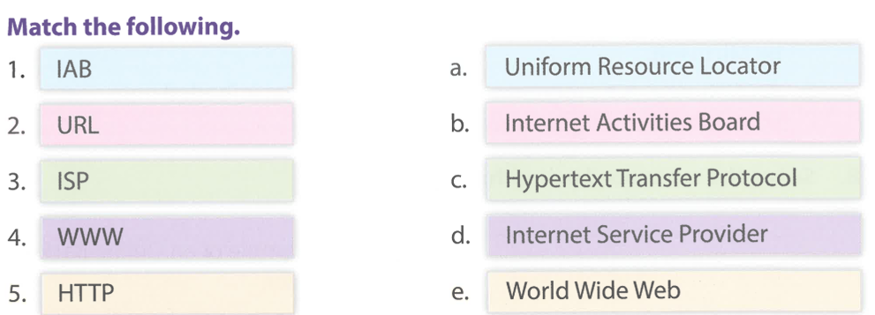
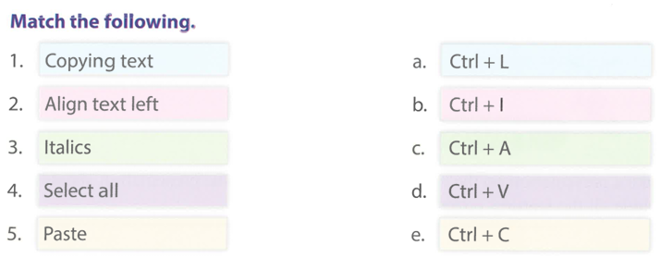
Answer the following questions.
- Explain any two uses of the internet.
Ans. Watching Videos and Shopping
- Name three governing groups of the internet.
Ans. IAB, IETF AND IRTF
- State the difference between a computer virus and an internet virus.
Ans. Computer Virus harm your Computer and Internet Virus is online Virus.
- List any three rules of netiquette.
Ans. Be nice, Don’t share false news, Be respectful
- Discuss the importance of Internet Explorer.
Ans. We can Visit Website with Internet Explorer
- What is meant by a slide transition?
Ans. Slide Transition adding effects in slides.
- What is meant by ‘moving’ and ‘copying’ a slide?
Ans. Moving is cutting and pasting and Copying is duplicating.
- What is meant by text alignment? Explain the different types.
Ans. Change text position left, right and center
- Write the steps to use Format Painter.
Ans. Select text and click on format painter and apply.
- How can you add graphics to a presentation?
Ans. Click on insert clip art and click on add picture.

