Grade 4 Computer Syllabus
CHAPTER 1

Q1. What are input devices?
Ans. Input devices enter data.
- Keyboard
- Mouse
- Touch screen
- Joystick

Q2. What are output devices
Ans. Output Devices give results.
- Monitor
- Speaker
- Printer
- Plotter
Q3. What is Central Processing Unit (CPU)
Ans. The Central Processing Unit is the brain of Computer.

Objective Questions
MCQs:

1. What is the main function of input devices?
A) To display data
B) To enter data
C) To process data
D) To store data

Answer: B) To enter data

2. Which of the following is an example of an output device?
A) Keyboard
B) Monitor
C) Scanner
D) Mouse

Answer: B) Monitor

3. What is the Central Processing Unit (CPU) also known as?
A) The heart of the computer
B) The brain of the computer
C) The memory of the computer
D) The power of the computer

Answer: B) The brain of the computer

4. Which device is used to capture images?
A) Scanner
B) Digital camera
C) Web camera
D) All of the above

Answer: D) All of the above

5. What do output devices provide?
A) Input data
B) Processed data
C) Results
D) Storage

Answer: C) Results

Chapter 2

Q1. what is Screen Saver?
Ans. Screen Saver shows moving pictures on a computer screen
Q2. What is Setting Date and Time?
Ans. Setting Date and Time Change a computer's clock to show the correct date and time.
Q3. What is Windows Explorer?
Ans. Windows Explorer manage files and folders in a computer.
Q4. What are Accessories?
Ans. Accessories are tools for example Notepad, Calculator, and Paint in windows.

Objective Questions
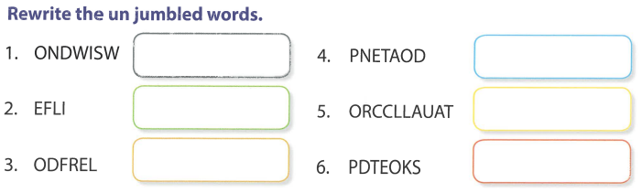
MCQs Choose correct answer
1. What does a Screen Saver do?
A) Protects the computer
B) Shows moving pictures
C) Manages files
D) Sets the time

Answer: B) Shows moving pictures

2. What is Windows Explorer used for?
A) Setting the time
B) Managing files and folders
C) Showing screen savers
D) Playing games

Answer: B) Managing files and folders

3. What are Accessories in Windows?
A) Games
B) Tools like Notepad and Calculator
C) Screen savers
D) Antivirus software

Answer: B) Tools like Notepad and Calculator

4. What does setting the Date and Time do?
A) Changes the background
B) Updates software
C) Sets the computer's clock
D) Manages files

Answer: C) Sets the computer's clock

5. Which is an example of an Accessory?
A) Windows Explorer
B) Screen Saver
C) Notepad
D) Game

Answer: C) Notepad
Practical Questions

1. Set up a Screen Saver on your computer to show a slideshow of your favorite photos.
2. Change the Date and Time settings on your computer to reflect the current date and time.

Chapter 3
Q1. What is FONT.
Ans. Fonts are letters (a,b,c,....), numbers ( 0,1,2,...) and Symbols (@, #,$).

Q2. What is Highlighting Text.
Ans. Highlighting text is making text visible.

Q3. What is Text Alignment.
Ans. Text Alignment is to move text Left, Right and center.

Objective MCQS Questions.
1. What is font?
A) A picture
B) A letter, number, or symbol
C) A sound
D) A video

Answer: B) A letter, number, or symbol

2. What is highlighting?
A) Making text invisible
B) Making text visible
C) Changing text size
D) Changing text color

Answer: B) Making text visible

3. What does text alignment do?
A) Changes font style
B) Changes font size
C) Moves text left, right, and center
D) Deletes text

Answer: C) Moves text left, right, and center

4. Which is an example of font?
A) A picture
B) A letter "A"
C) A sound
D) A video

Answer: B) A letter "A"

5. Why do we highlight text?
A) To make it invisible
B) To make it visible
C) To change its size
D) To change its color

Answer: B) To make it visible

Practical Questions.
1. Open a new document in MS Word and change the font of the text to "Arial" with size 14.
2. Highlight a paragraph of text in a document and change its background color to yellow.
3. Align a paragraph of text to the center of the page in a document.

Q. Fill with Correct one.
Subscript, Font Size, Bold, Superscript, Italic, Font color, Underline, Left Align, Font Color, Right Align, Strike Through, increase font Size, Font Box Launcher, Decrease font size
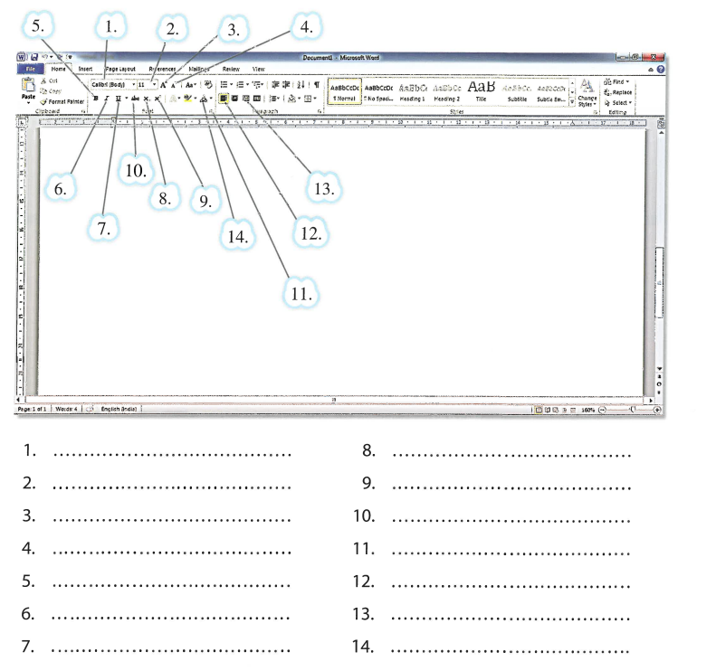

Chapter 4
Question Answers.
Q1. What is Tux Paint.
Ans. Tux Paint is used for painting.
Q2. What are Stamp Tool.
Ans. Stamp tool is used to select small picture in your painting.
Q3. What is Drawing Canvas.
Ans. Drawing Canvas is drawing area for painting.
Objective
fill-in-the-blanks:
1. Tux Paint is used for _________.
Answer: painting
2. The Stamp tool is used to select a small _________ in your painting.
Answer: picture
3. The Drawing Canvas is the _________ area for painting.
Answer: drawing

