Right Vision International School Tripoli- Libya
Monthly Test Syllabus.

MATHS
Mathematics pupils book:
Pages; 46,48,54,64,66.
Mathematics Workbook:
- Counting in numbers(from 51-100)
- Counting in words (from 10Ten -15 Fifteen).

ENGLISH
Unit 2 “A new room for Amy”
Language Book pages: 21, 22 and 23 (exercises 1 and 2)
Practice Book pages: 11 (exercise 2), 12, 14 and 15.

SCIENCE
Q1:- Fill in the blanks.
Key words
food
medicine

1. Many plants are good to eat, we use them as __________ .
2. Some plants help us when we are ill, we use them
as ________________ .

Q2:- Answer the following questions.
Q:- Write two uses of plants?
Ans:- Food and medicine.

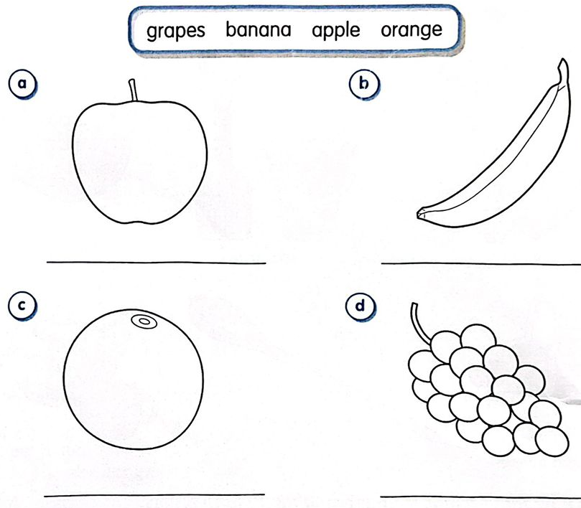
Q3:- Colour the fruits. Write their names underneath.

ARABIC

- اكتب الحروف من أ الى خ
- اكتب مواضع الحرف ل:
- ث( ................... ...................... .................)
- ج(.................... ...................... .................)
- ح(................... ..................... ...................)
- وصل الكلمات من العمود(أ) بما يناسبه من العمود(ب):

أَبي


تَاجٌ

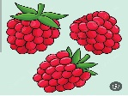
تُوتٌ

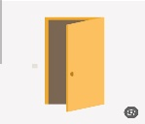
بَابٌ

- اكتب الصور العشرة ل:
- ث(........... .............. ............ .............. ............. .............. ................ .............. ............ ...........)
- ج(............. ............. ............. .............. ..............
............... ............... .............. .............. ............)

