Grade 5 Computer Solution

Fill in the blanks.

Duplicating the text means ........Copying.......... the selected text from one location and .... Paste........ it in another location.

......Alignment............ means to arrange the text according to a chosen pattern.

A ..........Theme.... is a template with a specific design that can be applied to a slide or to the entire presentation?

.......Image........... in a digital format are available from various sources such as scanned images, digital camera photographs and illustration software.

Clip Art are files of general purpose graphics consisting of ...Photo.......... and .....Illustration............

The Formula Bar displays the formula of an ........Active............. cell.

Columns in MS Excel are labelled as ........Letters..............

The mouse pointer changes to a ............Plus......... sign on the worksheet.

The ........Autofill............. feature helps us to generate a data series.

A cell can be resized using the ..........Auto fit........... option.

An .... Algorithm.............. is a step-by-step process of doing a task.

........Pseudo.......... means false code.

.......Loop........... is the process of repetition based on certain conditions.

The tools of the algorithm are ......Flowchart............ and ......Pseudo.............

.......Pseudo........... does not follow any standard for writing the instructions.

True or false?

You cannot resize the column width. False

The Delete dialog box shows three options. True

Left, Right and Center are the three types of vertical alignments in MS Excel 2010. False

The Auto Fill feature can be used with numbers only. False

Editing of cells can be done using the Cut, Copy, and Paste commands. False

Email is an online correspondence system. True

Downloading is generally used when you want to send photographs, articles or files to your friends, family, etc. False

The speed of a modem is measured in kilometers per second. False

Search results are usually presented in a list, and are commonly called hits. True

Internet Explorer is a series of graphical web browsers developed by Microsoft. True

The last step of every programming language is to write an algorithm. False

Flowcharts are the graphical representation of an algorithm. True

Flowcharts use numbers as symbols to represent an activity. False

Pseudocode is a formal language that helps non-programmers develop algorithms. False

When the flow of control of the program is based on a condition, we make use of a sequential algorithm. False

An Anti-virus is a program or piece of code that is loaded onto your computer without your knowledge. False
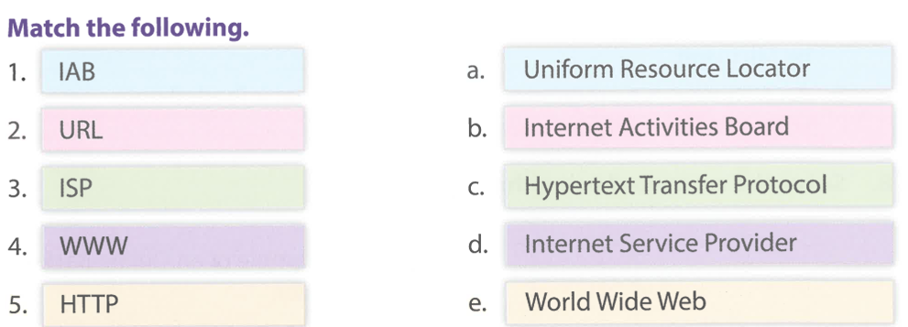
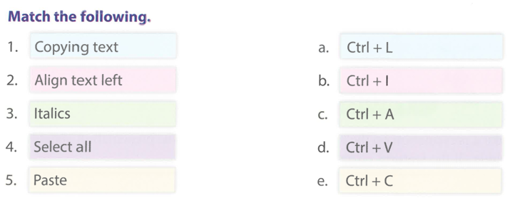

Answer the following questions.

Explain any two uses of the internet.
Ans. Watching Videos and Shopping

Name three governing groups of the internet.
Ans. IAB, IETF AND IRTF

State the difference between a computer virus and an internet virus.
Ans. Computer Virus harm your Computer and Internet Virus is online Virus.

List any three rules of netiquette.
Ans. Be nice, Don’t share false news, Be respectful

Discuss the importance of Internet Explorer.
Ans. We can Visit Website with Internet Explorer

What is meant by a slide transition?
Ans. Slide Transition adding effects in slides.

What is meant by ‘moving’ and ‘copying’ a slide?
Ans. Moving is cutting and pasting and Copying is duplicating.

What is meant by text alignment? Explain the different types.
Ans. Change text position left, right and center

Write the steps to use Format Painter.
Ans. Select text and click on format painter and apply.

How can you add graphics to a presentation?
Ans. Click on insert clip art and click on add picture.

