Right Vision International School Tripoli- Libya
Monthly Test Syllabus

ENGLISH
English language book:
Page# 29 (Exercise 1 Choose the correct past tense from the box. Write it next to the present tense verb.)
Page# 30 (Exercise 2 Read and circle true (T) or false (F))
From English practice book: Page# 24 (Full)

ARABIC
ص22 رقم (2)
ص 27
ص 28
ص 29

MATHS
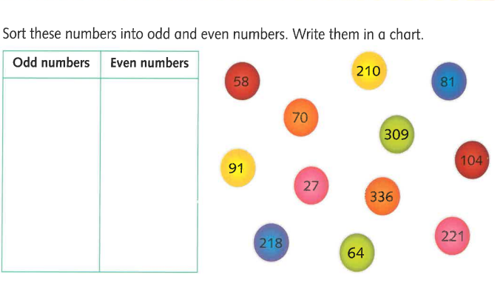
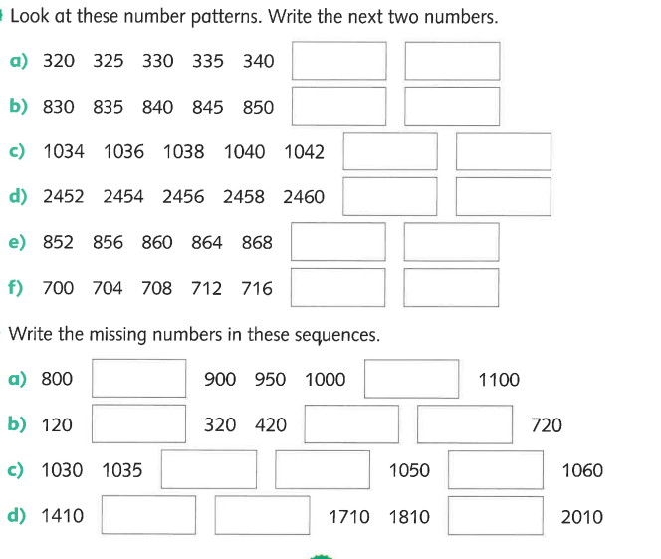
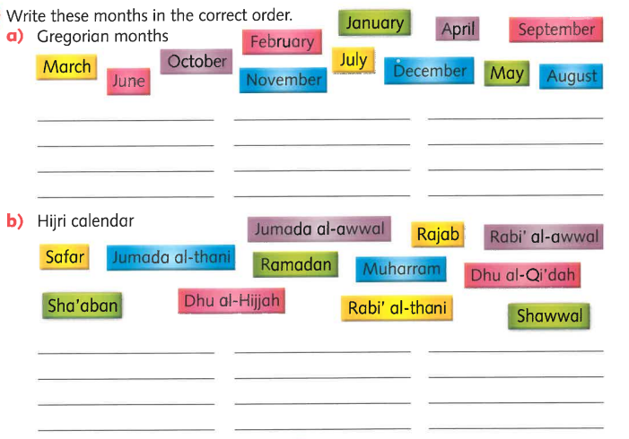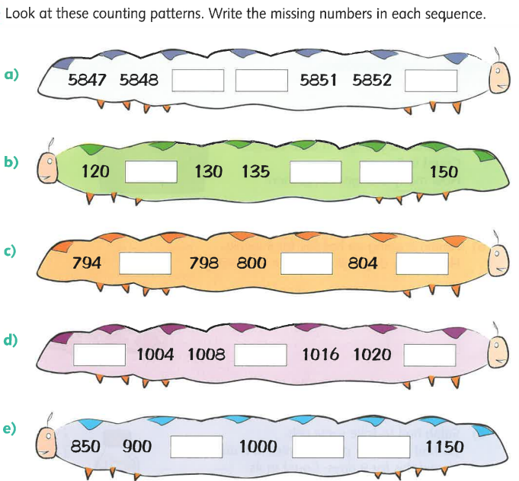
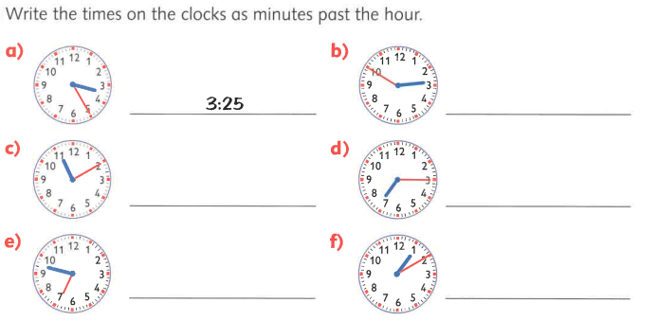
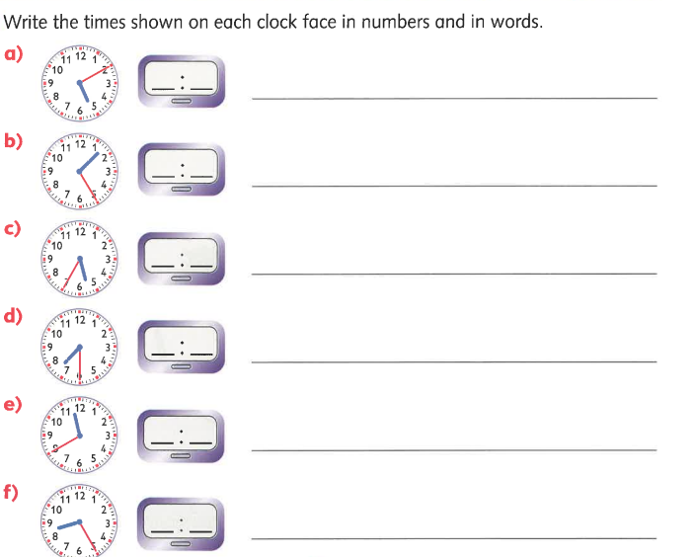
SCIENCE
Detailed syllabus of science grade 3
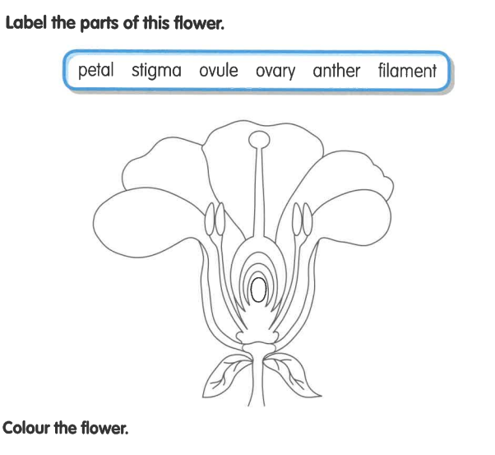
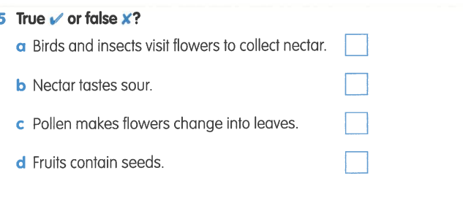
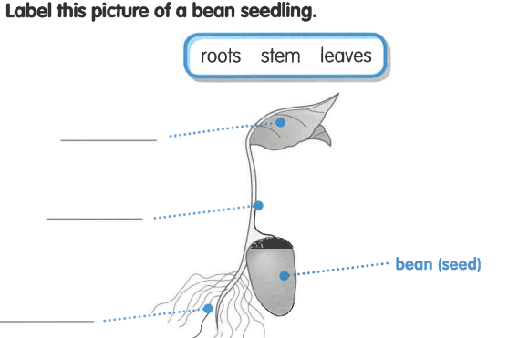
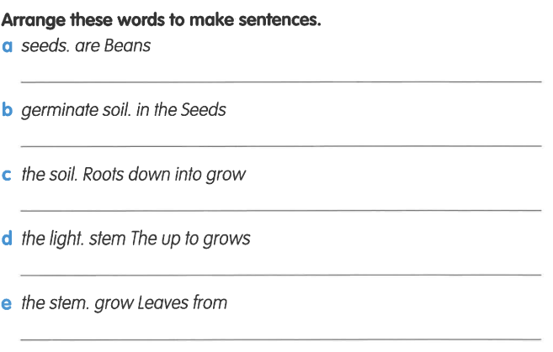
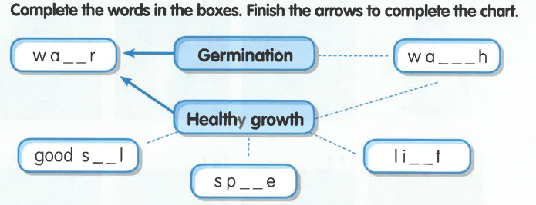
Question answers
Q1:What is nector?
Ans: Nector is a sweet liquid made by flowers to attract insects.
Q2: What does a fertiliezed flower become?
Ans: A fertiliezed flower become a fruit.

Q3: Whar is germination?
Ans: Germination is when a seed starts to grow into a new plant.
Q4: What are the conditions for germination?
It needs:
1:Water
2:warmth
3:Air
4:Space

