Revision worksheet for grade 6
Unit 3:
P.40 Complete the sentences with the words in the box:
Phanerozoic eon | Archaeon eon | Hadean eon | Proterozoic eon
a- The continents we know today were formed in the …………………………...
b- The whole Earth was hot and there were many volcanoes …………………..
c- Oxygen built up in the Earth’s atmosphere ………………………….
d- Microscopic living things first appeared ……………………………
How do we know how old the Earth is?
………………………………………………………………………………………………………………………………………………………………………………
Match the definitions with the words in the box:
Pangaea | era | Mesozoic | Period
a- The era in the Earth’s history during which the dinosaurs were the dominate animal group …………………………
b- A division of an eon …………………………..
c- A division of an era …………………………..
d- A supercontinent which has separated to become the continents we know today …………………………..
P.42 Match the definitions with the words in the box:
temperature | pressure | Humidity
a- The force per unit area that the atmosphere exerts on everything beneath it …………………………
b- A measure of the amount of water vapour in the air …………………..
c- A measure of how hot or cold something is …………………..

What is a depression?
………………………………………………………………………………………………………………………………………………………………………………
P.44 Match the definitions with the words in the box:
Polar | temperate | Mediterranean | Desert
a- Hot and dry throughout the year …………………………………
b- Very cold throughout the year ……………………………….
c- Long hot summers, mild winters with some rain …………………………
d- Changeable , generally cool with rain at any time of year ……………………….
What is Khamsin? How can it harm the living things?
………………………………………………………………………………………………………………………………………………………………………………………………………………………………………………………………………
Unit 4
P.49 Mark each of these statements as true ( T ) or false ( F )
1- Coal, oil and gas are different types of fossil fuel ( )
2- Most of the electricity we use is generated by batteries ( )
3-Food is an energy source for growth and movement ( )
4-Hot underground rocks are the ultimate source of most of our energy ( )
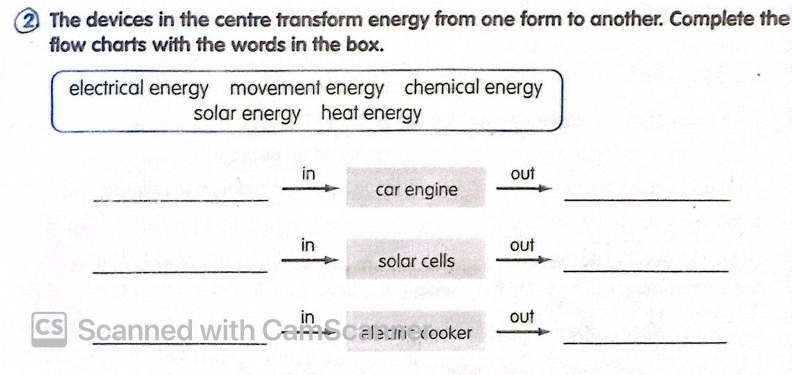
P. 50 Match the definitions with the words in the box
(Fossil fuels - petroleum-natural gas- frictional distillation )
a- A gaseous fossil fuel which is mainly the gas methane ……………………………..
b- A method for separating a mixture of liquids and gases that have different boiling temperatures …………………………………………
c- Fuels created from the buried remains of plants and animals by the action of pressure and heat …………………………………………
d- The fossil fuel also known as crude oil ……………………………..
Mark each of these statements as true ( T ) or false ( F )
a- Crude oil is separated into different components on an oil rig ( )
b- Oil and natural gas were created from the bodies of sea plants and animals ( )
c- We use most of the petroleum recovered from oil wells to manufacture plastics( )
Write the name of the fractions separated from petroleum at the correct outlets of the fractionating column . Use the words in the box:
( bitumen – diesel- gases- kerosene- naphthalene – oils- petrol)
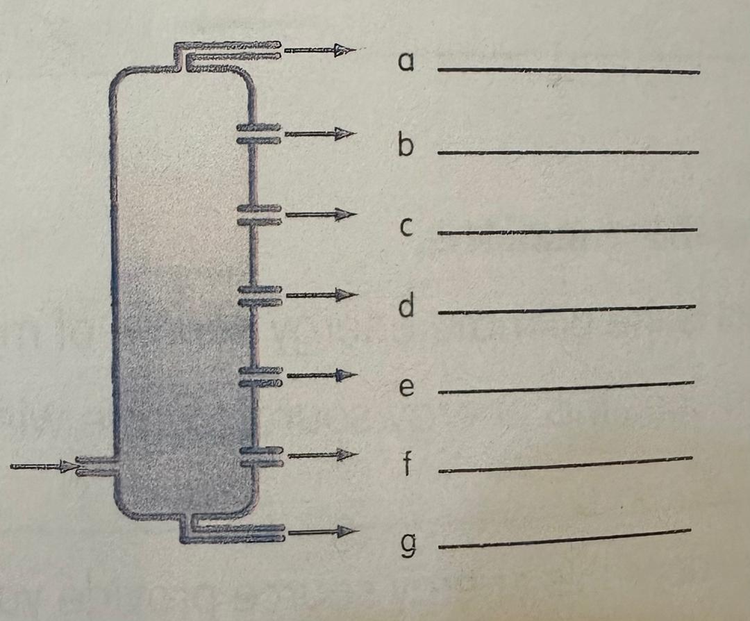
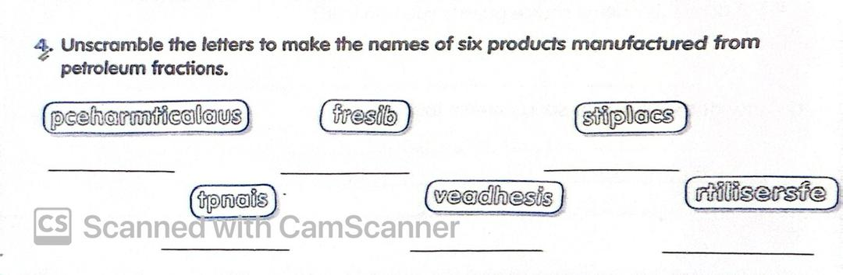
What is the main use for natural gas and petroleum products?
……………………………………………………………………………………………………………………………………………………………………………………………………………………………………………………………………….
What is the ultimate energy source of most of the energy we use?
………………………………………………………………………………………………………………………………………………………………………………

P.54 Write whether the mirror is convex or concave under each picture:
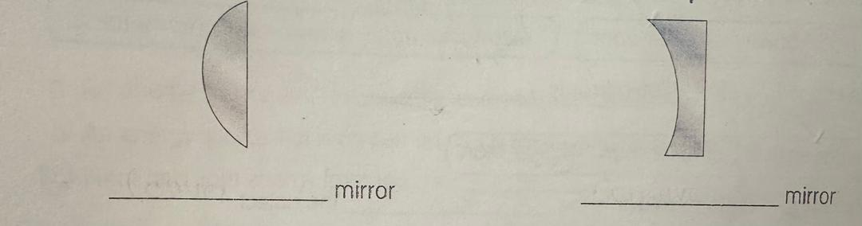
Describe two different ways in which mirrors
are useful?
………………………………………………………………………………………………………………………………………………………………………………………………………………………………………………………………………………………………………………………………………………………………

P.57 Find the five optical instruments in this word square: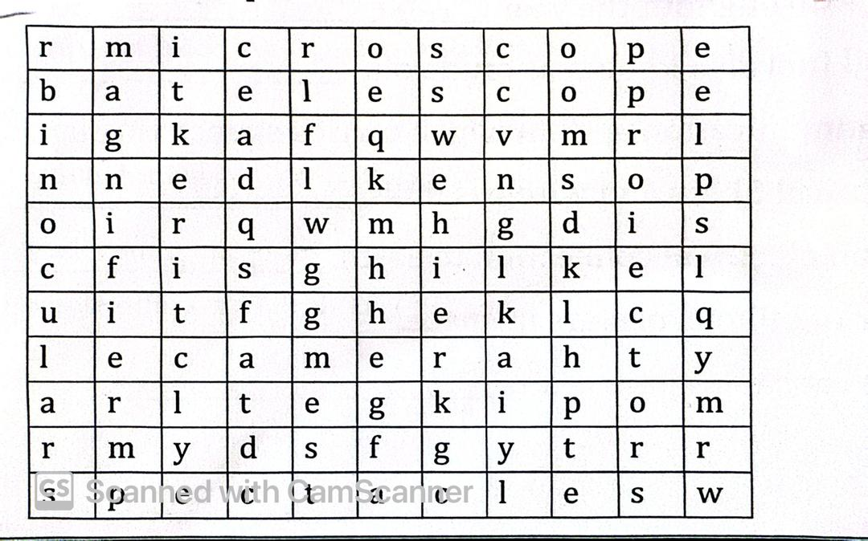
Define optical instruments? Give an example
………………………………………………………………………………………………………………………………………………………………………………………………………………………………………………………………………
P.59: Match the definitions with the words in the box:
sound | waves | vibrations | Vacuum
1- Rapid to and fro movements …………………………………..
2- Empty space that contains no matter, not even air ……………………..
3- Repeated up and down or to and fro movements that travel away from a wave source and carry energy from place to place …………………………….
4- The form of energy that travels as waves through the air and other materials, causing us to hear when it enters our sound ……………………………….
How does a sound travel from a drum to your ear?
………………………………………………………………………………………………………………………………………………………………………………………………………………………………………………………………………

P.65
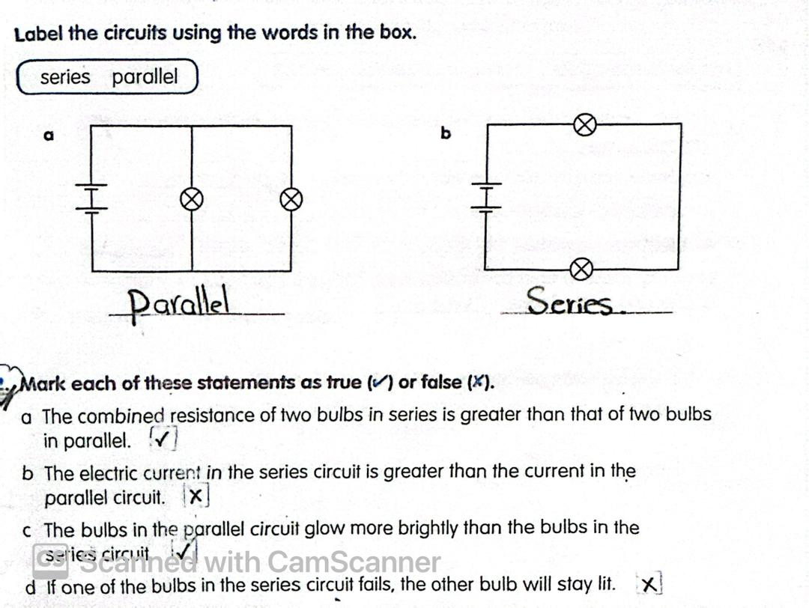
Define circuits?
……………………………………………………………………………………………………………………………………………………………………………………………………………………………………………………………………….
P.70
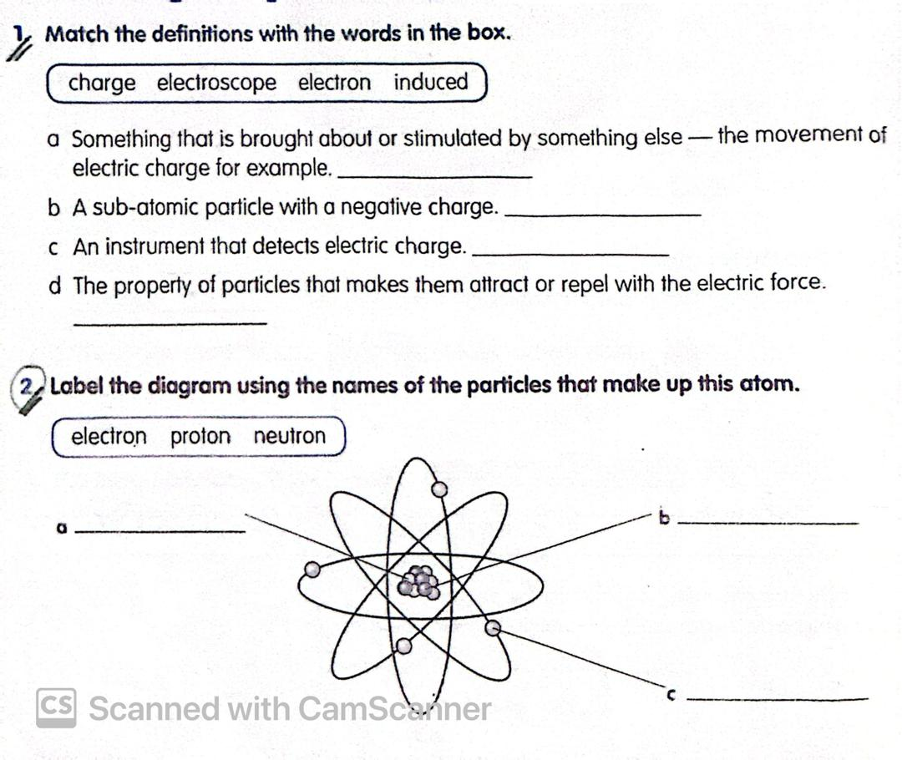
Define electron?
………………………………………………………………………………………………………………………………………………………………………………
What is electroscope?
………………………………………………………………………………………………………………………………………………………………………………
What is static electricity?
……………………………………………………………………………………………………………………………………………………………………………….
What is electric charge?
………………………………………………………………………………………………………………………………………………………………………………
P.72: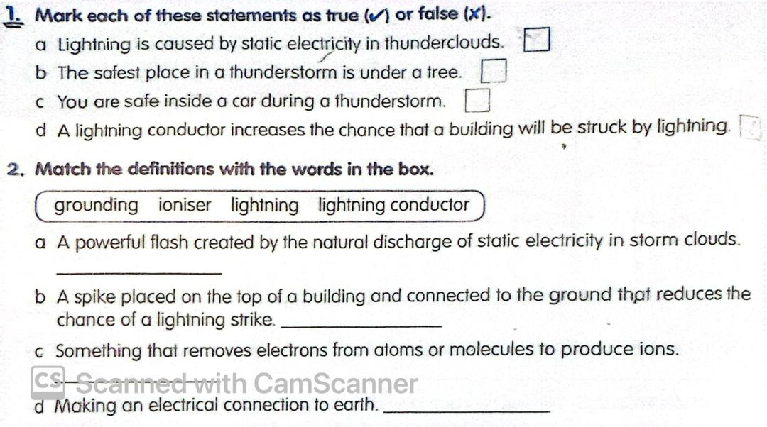
Explain magnetic field?
………………………………………………………………………………………………………………………………………………………………………………
P.77
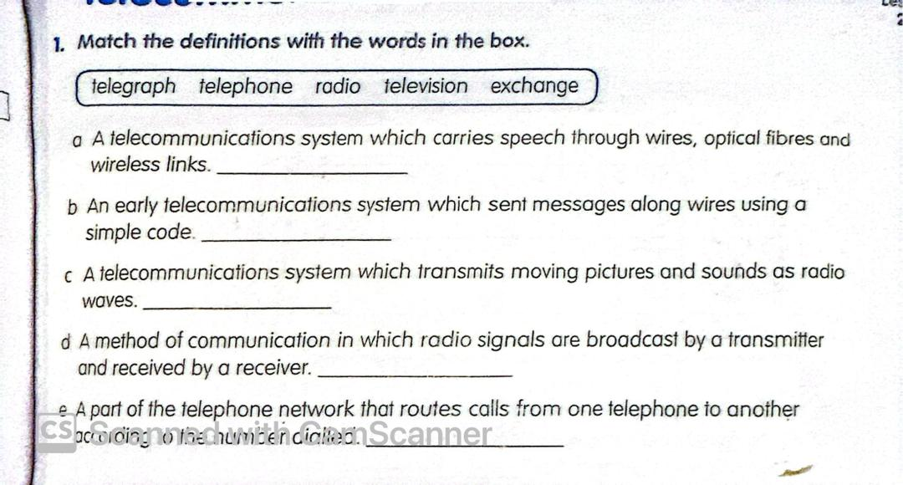
What is a telegraph? How did it carry messages?
………………………………………………………………………………………………………………………………………………………………………………………………………………………………………………………………………
Unit 5
P.88 Match the definitions with the words in the box:
star | supernova | Galaxy

1- ……………………………… a cluster of billions of stars in space.
2- …….. enormous balls of matter in space that give out huge quantities of energy.
3- …………………………… an explosion of a large star at the end of its life.
- Match the object to the descriptions:
A | B
1- Proxima Centauri | a- a star that has expanded and cooled towards the end of its life
2- Andromeda | b- Our galaxy
3- red giant | c- The next nearest galaxy to our galaxy
4- The Milky Way | d- The closest star to the Earth after the sun

P.90
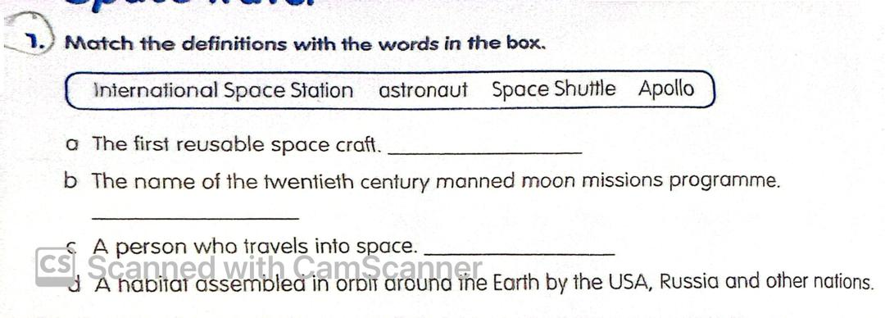
Write whether T or F:
1- The first ever space craft was Apollo ( )
2- A person who travels into space is an astronomer ( )
3- The space shuttle is a habitat assembled in orbit around the earth by the USA, Russia and other nations ( )
4- Astronauts need to exercise regularly ( )
What is the ISS? Where is it?
……………………………………………………………………………………………………………………………………………………………………………

