Grade 6
True or false?
- The internet is a network of computers. TRUE
- Universal Resource Locator is the full form of URL. FALSE
- The email address is a combination of a username and a hostname. TRUE
- DNA is a medium of sending mails through the internet. FALSE
- A file sent in an email is called an attachment. TRUE
- By default, the name of the program file in QB64 is ‘Untitled’. TRUE
- BES is the extension of a QB64 program. FALSE
- QBASIC is designed from BASIC language. TRUE
- The ‘Exit’ option is used to save the changes in the program file. FALSE
- To exit from QB64, use the New option found in the File menu. FALSE
- Commas and semicolons are the two separators used with PRINT statements. TRUE
- Print is a name of the memory location. FALSE
- Variables are non-executable statements. FALSE
- To accept a value from the user, an input statement is used. TRUE
- % sign is used with string variables. FALSE
- Relational operators are used for combining two or more conditions. TRUE
- Logical operators are used when you want to make a comparison between any two values. TRUE
- The IF command is used for executing a statement based on the condition. TRUE
- Arithmetic operators are also called concatenation operators. FALSE
- Relational operators give a single value, which is either true or false. TRUE
Fill in the blanks.
- Numbers entered in MS Excel 2010 could be a value, ___DATE_____________ or ___________TIME_____ .
- You can format data using the ____FORMAT____________ option.
- Addition of two strings is called _______Concatenation_________ .
- ______#name__________ error message is displayed when the text is not recognized.
- ____Math and String____________ option can be used to find the GCD and LCM of two numbers.
Give one word for the following:
- Blind carbon copy BCC
- Worldwide system of servers WSS
- Username@hostname EMAIL ADDRESS
- Unique address of a website URL
- Email server name HOSTNAME

Give one word for the following:
- Runs a program. __________RUN _ COMMAND_____________
- File extension in QB64. _________.BAS_______________
- Helps to give a name to a file. _________SAVE_______________
- Changes are saved. __________SAVE AS______________
- Command for clearing the screen. _______CLS_________________
- Command to display the output on the screen. ________PRINT________________
Write the formulae to get the following results.
- Add the values from cell A2:D2 and display the result in E2.
- Find the average of values from C2:E2.
- Find the minimum value from the numbers given in cells A2:A4.
- Find the maximum value from the numbers given in cells B1:B6.
- Find the count of values from cells A5:E12.
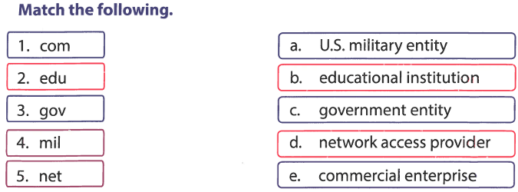

Question Answers.

What is QB64? How is it related to QBASIC?
Ans. QB64 is modern version of QBASIC.

Name the different components of the QB64 window.
ANS. 1. TITLE BAR, 2. Menu Bar 3. vertical scroll bar

What command do you give to clear the output screen?
Ans. CLS command is used to clear the screen.

How do you execute a program in QB64?
Ans. RUN command is used to execute a program.

Why do you use the Save As... option?
Ans. Save as is used to save a file with new name.

What is a URL? Explain its format.
Ans. URL is website name. www.google.com

Why do you need an email address?
Ans. To send and receive emails.

State the advantages and disadvantages of using email.
Ans. Advantage: Fast Disadvantage: You need internet

What do you mean by ‘composing an email’?
Ans. Composing an email is writing the email.

Why is it advisable to sign out of your email account properly?
Ans. To protect your account from thief.

