Right Vision International School Tripoli- Libya
Monthly Test Syllabus
MATHS
Mathematics Pupils Book:
Pages: 28,32,36,38,42,45.

ENGLISH
☆ English language book:
Page# 38 (Full)
☆ English practice book:
Page# 26 ( Exercise 2 Circle the correct answer.)
Page# 28 (Exercise 2 Complete the sentences with him or her.)

SCIENCE
Q1:- Fill in the blanks.
1. Things made from plants are called plant __________ .
2. We can use papyrus reeds to make ___________ .
Q2:- Rearrange the letters. Find the names of these plant products.
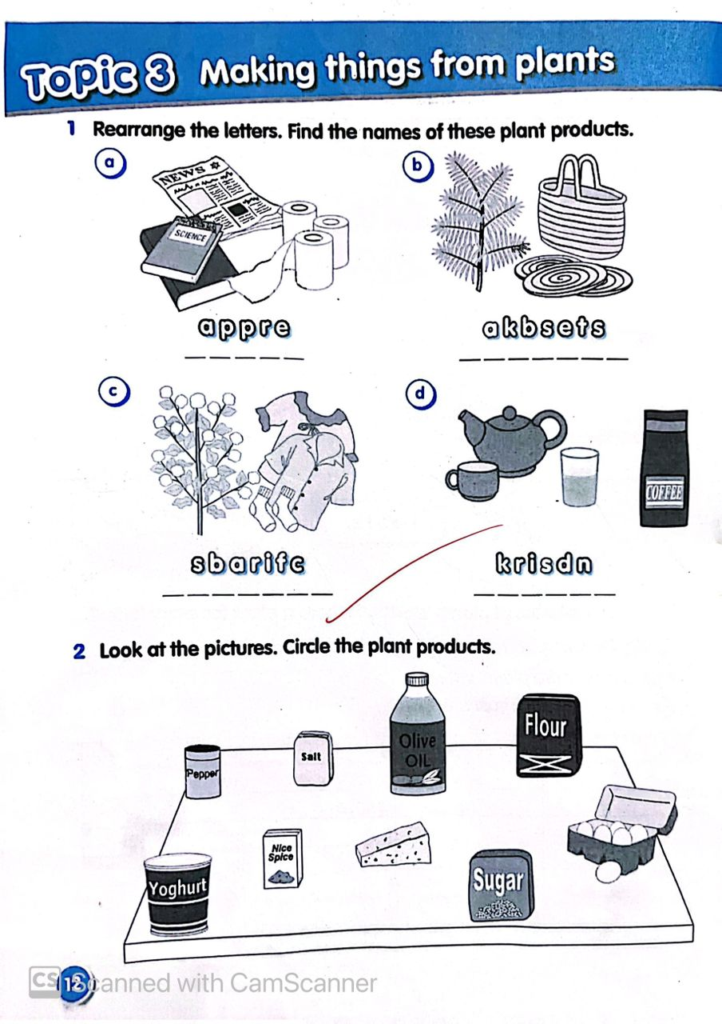

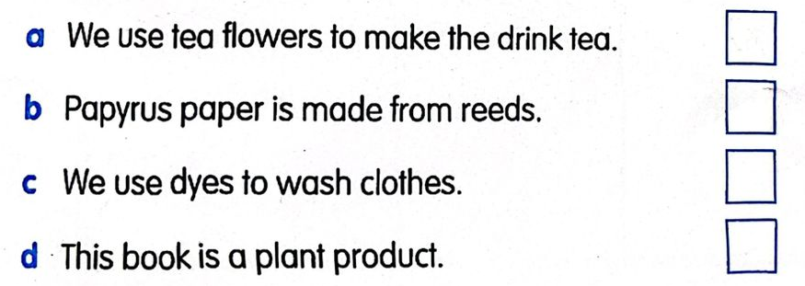
Q3:- True or false?

ARABIC
- اختر الاجابة الصحيحة (صفحة 34)
- رتب الجمل الاتية:
- نحن – الصّفّ– في – الثّاني ...................................
- هو - الصّّفّ– في – الأوّل ....................................
- أنتَ – الصّفّ – في – الثّالث ....................................
- فكك الكلمات التية:
مُعَلِّمَةٌ - طَلَبَتْ - جَالَتْ -العُشّ – الصَّغِيرُ - الْجَدّةُ

