- Choose and write
  - Billy is a ………Boy………. ( Boy , Girl )
  - Billy’s mum is in the ……Kitchen…… ( Sitting room , Kitchen )
  - Billy’s mum is making a …Cake……. ( Clock , Cake)
- Complete the sentences
  - Billy is …Drawing……… a Dog ( Drawing , Making )
  - Zoe …is….. ……Cutting……. The paper ( Cutting , Drawing )
- Complete the sentences with (am , is or are )
  - …Are………. You making a cake?’ Yes, I …am…
  - Ben and Sam ……are……. Swimming
  - Nina …is…. Writing an email.
  - …Are…. You having fun? ‘ Yes, we …are…
- Complete the sentences
  - I can …see…... a …bee… in a …tree…..
  - I can …see….. a …bee….. under a …tree….

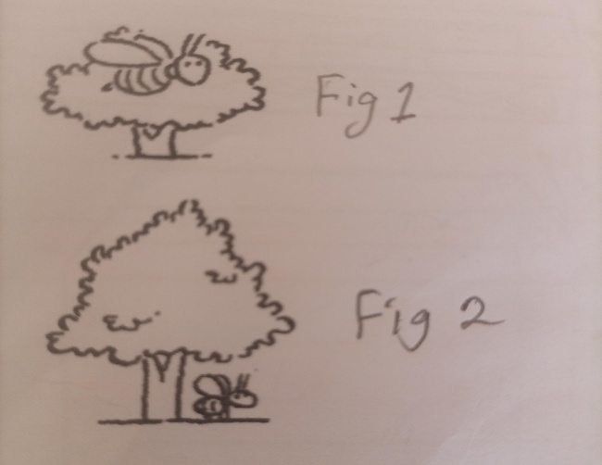
- Underline only adjective in the sentences
- Nina and Ben are watching the fast Car
- Tilly is riding a dirty bicycle
- The dog is eating an old shoe
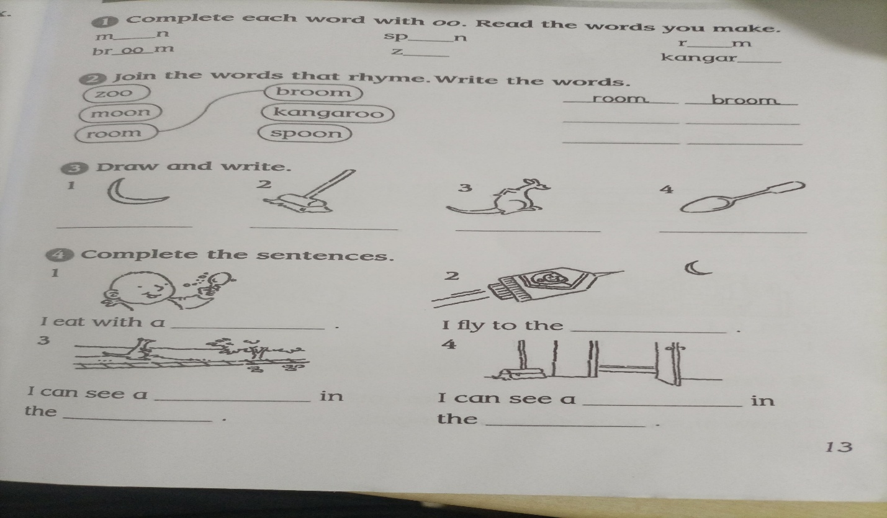

  - Answers: Moon , Spoon , Room , Broom
Zoo ,. Kangaroo

  - Answer room broom
Zoo Kangaroo
Moon Spoon
  - I eat with a Spoon
I fly to the moon
I can see a Kangaroo in the Zoo
I can see a Broom in the room

