Revision worksheet for grade 5
Unit 3:
P.35 Mark each of these as true ( T ) or false ( F ):
a- Water from some sources may be polluted with germs ( )
b- Polluted water spreads disease ( )
c- Water can be made safe by boiling or by treating it with chemicals ( )
d- It is safe to drink water straight from a river or a canal ( )
P.41: Mark each of these as true ( T ) or false ( F ):
a- The force of gravity holds the atmosphere around the Earth ( )
b- Oxygen is the most abundant ( common) gas in the atmosphere ( )
c- Most of the air that makes up the atmosphere is within 30 kilometers of the Earth’s surface ( )
d- The higher you rise in the atmosphere, the hotter it gets ( )

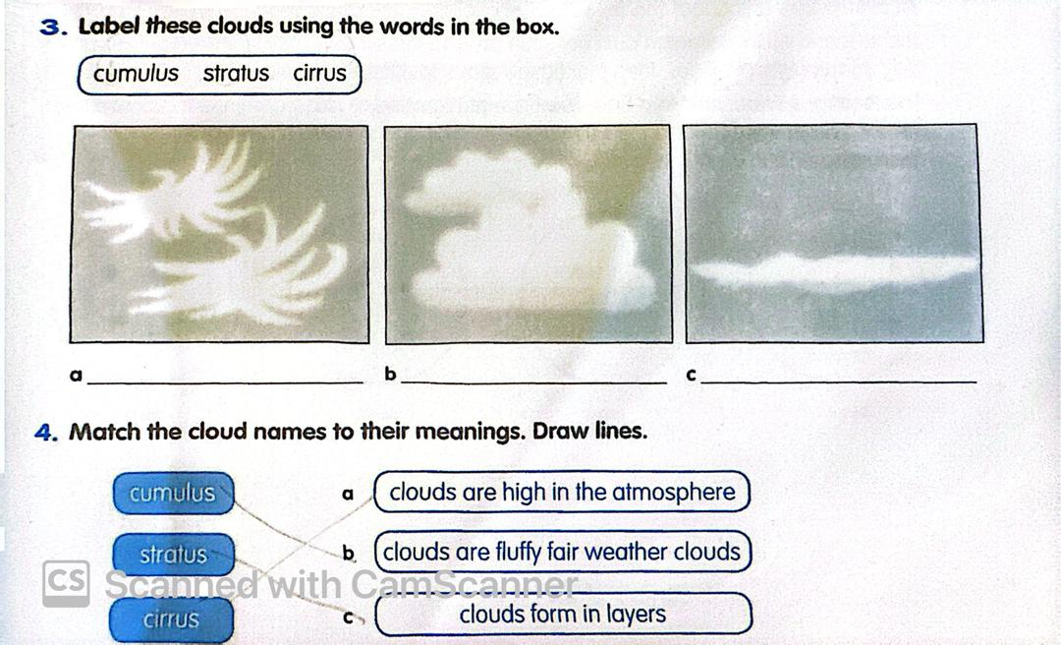

P.42
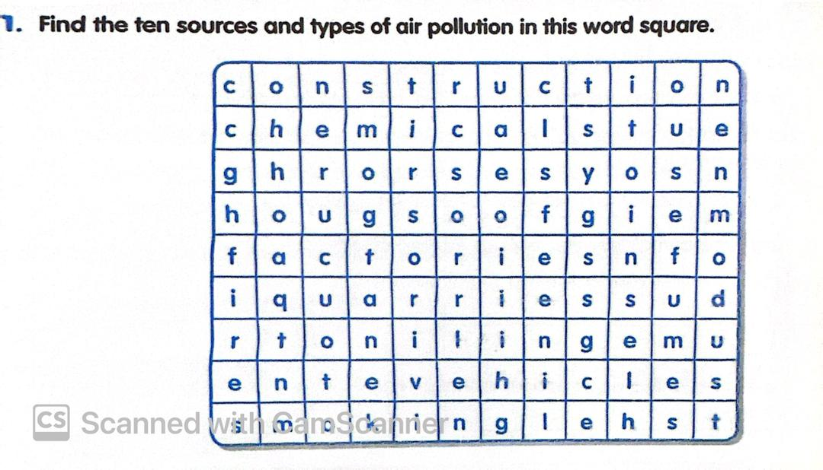
List any four different sources of air pollution?
………………………………………………………………………………………………………………………………………………………………………………………………………………………………………………………………………
P.44: What is the purpose of an air filter?
………………………………………………………………………………………………………………………………………………………………………………
Explain briefly how an air filter works?
………………………………………………………………………………………………………………………………………………………………………………………………………………………………………………………………………
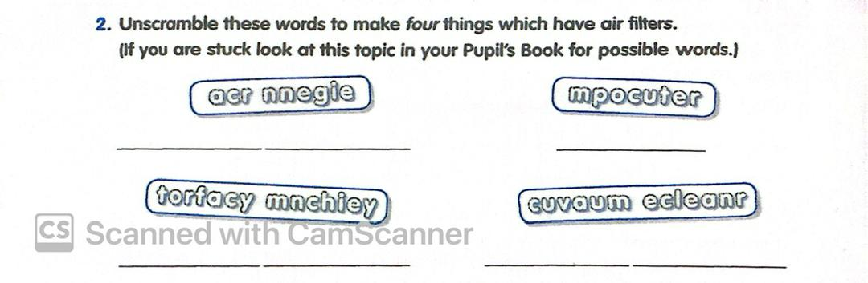

P.47
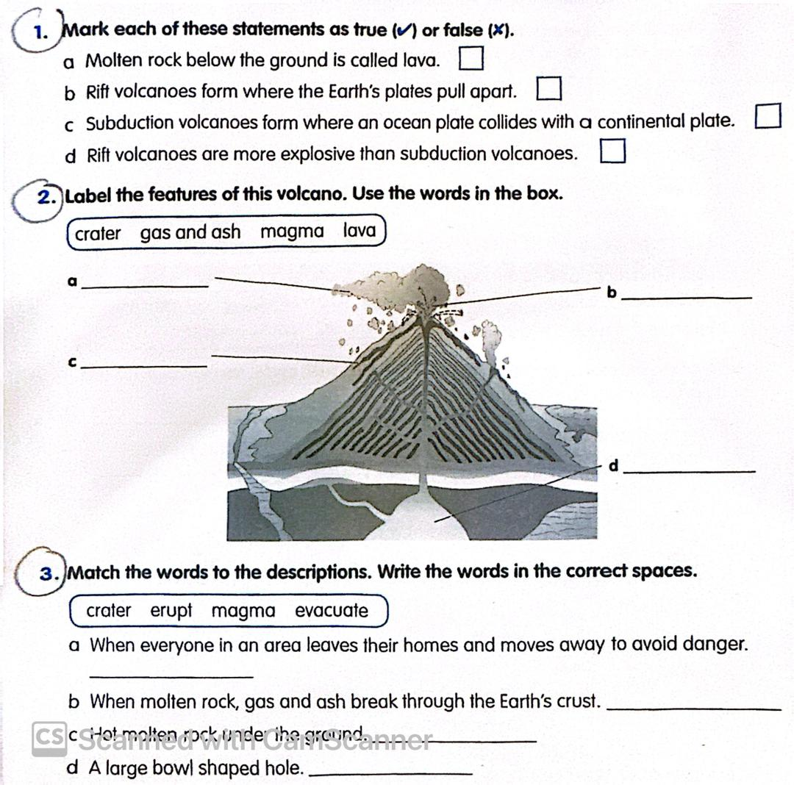
What happens when a volcano erupts?
………………………………………………………………………………………………………………………………………………………………………………
Unit 4
Match the type of motion to the description. Write the words in the correct spaces:
( translation-cam- oscillation- rotation )
a- Repeated to – and – fro movement ………………………………………………….
b- Turning motion around an axle ………………………..
c- Motion in a straight line ………………………………….
d- A ……… changes rotation into oscillation.

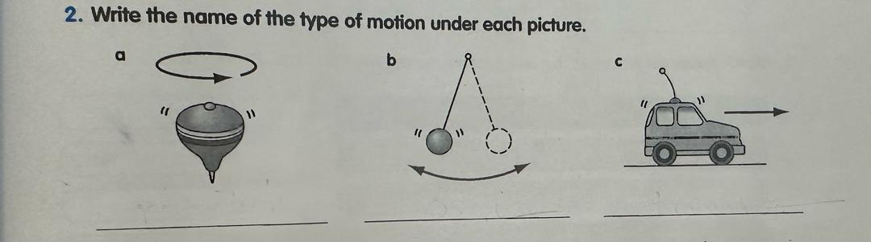
Q1- Name three machines on a modern building site that had not been invented 150 years ago?
………………………………………………………………………………………………….
Q2- What is a complex machine?
………………………………………………………………………………………………………………………………………………………………………………

P.65
Q2- Choose the correct words from the brackets to fill the gaps:
a- Levers , pulleys and wheels are examples of …………… machines
( old- simple – complex )
b- A ………….. machine is built from two or more simple machines.
( complex- large- modern )
c- A bicycle is an example of a …………… machine . ( simple- basic- complex)
d- Many of the modern machines we use in the home are powered by …………. ( electricity – steam- water)
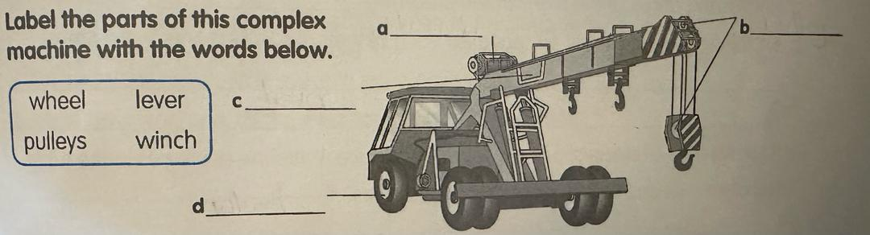
P.71 Mark each of these as true ( T ) or false ( F ):
a- The image in a plane ( flat ) mirror is upside down ( )
b- The image in a plane mirror is back – to – front ( )
c- The angle at which a mirror reflects light is equal to the angle at which the light is incident on the mirror ( )
d- The image in a curved mirror is always smaller than the object ( )
P.73 Match the words to their definitions . Write the words in the correct spaces:
( pupil- iris- cornea- lens- retina- optic nerve )
a- The light – sensitive layer that covers the inside surface of the back of the eye ………………
b- The black aperture ( hole) at the centre of the iris through which light passes into the eye …………….
c- The nerve that carries information from the eye to the brain ……………………
d- The transparent disc that changes thickness to focus on objects at different distances. ………
e- The coloured ring that surrounds the pupil …………….
f- The outer surface of the eye …………………..
Q2- Mark each of these statements as true ( T ) or false ( F ):
a- Information from the eye travels as electrical pulses to the brain ( )
b- The lens focuses an image on to the cornea ( )
c- The image produced by the lens is upside down ( )
d- The point closest to the eye at which you can see clearly is called the far point ( )
P.74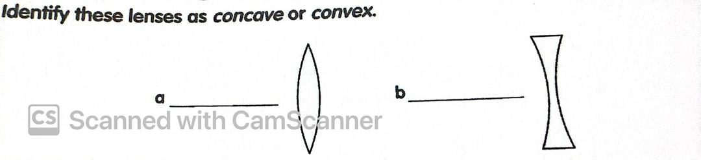
Describe three different ways in which mirrors are useful?
………………………………………………………………………………………………………………………………………………………………………………………………………………………………………………………………………………………………………………………………………………………………………………………………………………………………
Give two examples each of transparent, translucent and opaque material?
………………………………………………………………………………………………………………………………………………………………………………………………………………………………………………………………………………………………………………………
P.77 Mark each of these statements as true ( T ) or false ( F ):
a- There are two kinds of electric charge ( )
b- A positive charge repels a negative charge ( )
c- A negative charge attracts a positive charge ( )
d- A charged object repels an uncharged object ( )
What is static electricity ?
………………………………………………………………………………………………………………………………………………………………………………………………………………
P.78 Write the name of the component under each symbol. Use the words in the box:
( cell – wire- battery- motor- bulb- switch- buzzer )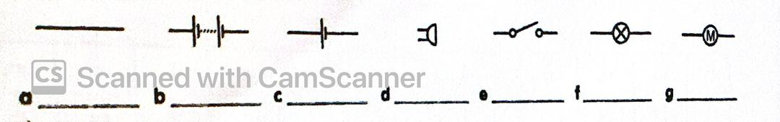
P.82 Mark each of these statements as true ( T ) or False ( F ):
a- Every magnet has two poles ( )
b- The magnetic force is weakest at the poles ( )
c- A north pole repels a south pole ( )
d- A south pole attracts a north pole ( )

Unit 5
P.88 Q1- Use the words below to label this diagram:
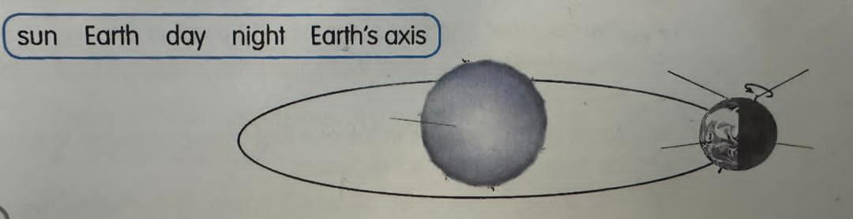
Q2- Mark each of these statements as true ( T ) or false ( F ):
1- The Earth takes one day to make one orbit of the sun ( )
2- One year is the time the Earth takes to make one orbit of the sun ( )
3- In December it is winter in the southern hemisphere ( )
4- The Earth spins on its axis once each day ( )
P.89:Q2 - Mark each of these statements as true ( T ) or false ( F ):
a- A new moon is very bright ( )
b- The moon takes just over 27 days to orbit the Earth ( )
c- The moon is hot ball of gas ( )
d- The moon is a cold ball of rock ( )
- Define moon: ………………………………………………………………………………………………………………………………………………………………………………………………………………
- The moon does not give out light, Explain how we can see it?
………………………………………………………………………………………………………………………………………………………………………………………………………………
- Describe the motion of moon around the earth?
………………………………………………………………………………………………………………………………………………………………………………………………………………
………………………………………………………………………………………………………

